**Topics: Normal distribution, Functions of Random Variables**

1. The time required for servicing transmissions is normally distributed with *μ* = 45 minutes and *σ* = 8 minutes. The service manager plans to have work begin on the transmission of a customer’s car 10 minutes after the car is dropped off and the customer is told that the car will be ready within 1 hour from drop-off. What is the probability that the service manager cannot meet his commitment?
2. 0.3875
3. 0.2676
4. 0.5
5. 0.6987

**ANSWER** = B. **0.2676**

1. The current age (in years) of 400 clerical employees at an insurance claims processing center is normally distributed with mean *μ* = 38 and Standard deviation *σ* =6. For each statement below, please specify True/False. If false, briefly explain why.
2. More employees at the processing center are older than 44 than between 38 and 44.

**ANSWER**= **FALSE**

According to problem statement : case1 > case2, and after applying a statistic method we can say that it is not a true statement.

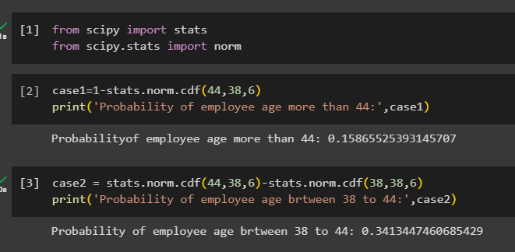

1. A training program for employees under the age of 30 at the center would be expected to attract about 36 employees.

**ANSWER** = **TRUE**

1. If *X1* ~ *N*(μ, σ2) and *X*2 ~ *N*(μ, σ2) are *iid* normal random variables, then what is the difference between 2 *X*1 and *X*1 + *X*2? Discuss both their distributions and parameters.

**ANSWER**: The difference between 2X1 and (X1+X2) is the magnitude they contain for two different sample’s subsets X1 and X2 from the same population.

Any large number of i.i.d random variables are approximately normal, hence (X1+X2) and 2X1 both are normally distributed.

1. Let X ~ N(100, 202). Find two values, *a* and *b*, symmetric about the mean, such that the probability of the random variable taking a value between them is 0.99.
2. 90.5, 105.9
3. 80.2, 119.8
4. 22, 78
5. 48.5, 151.5
6. 90.1, 109.9

ANSWER = D. 48.5, 151.5

1. Consider a company that has two different divisions. The annual profits from the two divisions are independent and have distributions Profit1 ~ N(5, 32) and Profit2 ~ N(7, 42) respectively. Both the profits are in $ Million. Answer the following questions about the total profit of the company in Rupees. Assume that $1 = Rs. 45
2. Specify a Rupee range (centered on the mean) such that it contains 95% probability for the annual profit of the company.
3. Specify the 5th percentile of profit (in Rupees) for the company
4. 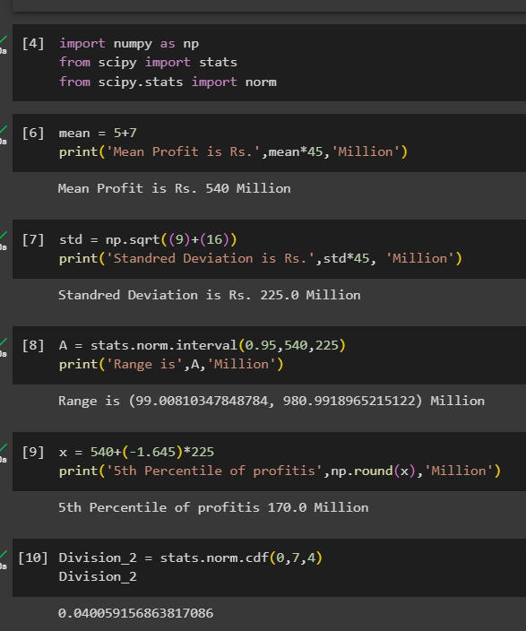Which of the two divisions has a larger probability of making a loss in a given year?